Navigation and File Manipulation:

cd ~ && mkdir exercises && cd exercises: Navigate to your home directory, create a new directory named "exercises," and then move into it.

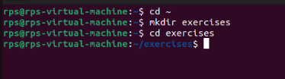

cp ../data.txt . (assuming "data.txt" exists in the parent directory): Copy a file named "data.txt" from the parent directory into your current "exercises" directory.

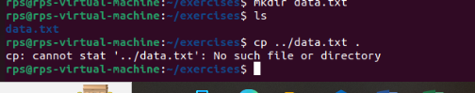

mv important_file.txt important_data.txt && touch report.md: Rename a file named "important_file.txt" to "important_data.txt" and create a new Markdown file named "report.md" within the "exercises" directory.

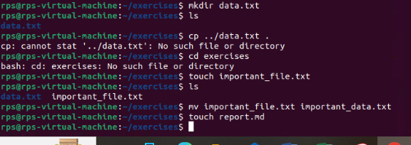

cat report.md (assuming the file is empty): View the contents (which should be empty) of the "report.md" file using cat.

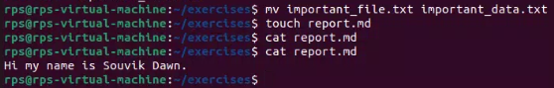

echo "This is a report" >> report.md: Append a line of text "This is a report" to the "report.md" file using redirection ('>>').

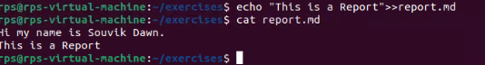

less report.md: Use less to view the contents of the "report.md" file, which now contains the appended text.

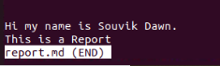



Finding and Organizing Files:

ls -l | grep 'txt$': List all files in the current directory with the long format (-l) and filter the output using grep to only show files ending with the ".txt" extension.

find . -name 'data*': Search for all files starting with "data" (including "data.txt", "data_backup.csv", etc.) recursively within the current directory and its subdirectories using find.

mv data* data_archive/: Move all files starting with "data" into a new directory named "data_archive" (create it if it doesn't exist).

